SENT TO SERVE

SONG: “All Hail The Power Of Jesus' Name” (Coronation)
Verse 1
All hail the pow'r of Jesus' name, Let angels prostrate fall
Bring forth the royal diadem, And crown Him Lord of all
Bring forth the royal diadem, And crown Him Lord of all
Verse 2
Ye chosen seed of Israel's race, Ye ransomed from the fall
Hail Him who saves you by His grace, And crown Him Lord of all
Hail Him who saves you by His grace, And crown Him Lord of all
Verse 3
Sinners whose love can ne'er forget, The wormwood and the gall
Go spread your trophies at His feet, And crown Him Lord of all
Go spread your trophies at His feet, And crown Him Lord of all
Verse 4
Let ev'ry kindred ev'ry tribe, On this terrestrial ball
To Him all majesty ascribe, And crown Him Lord of all
To Him all majesty ascribe, And crown Him Lord of all
Verse 5
O that with yonder sacred throng, We at His feet may fall
We'll join the everlasting song, And crown Him Lord of all
We'll join the everlasting song, And crown Him Lord of all
Verse 6
Crown Him ye morning stars of light, Who fixed this earthly ball
Now hail the strength of Israel's might, And crown Him Lord of all
Now hail the strength of Israel's might, And crown Him Lord of all
Edward Perronet, John Rippon, Oliver Holden, CCLI Song #25400, © Words: Public Domain; Music: Public Domain
For use solely with the SongSelect® Terms of Use. All rights reserved. www.ccli.com

BENEDICTION

POSTLUDE

Thank you for worshiping with us at TCC!
Pastor: Rev. Caroly Gibson
Music Minister: Ilana Ofgang, Ilana.ofgang@trumbullcc.org

TRUMBULL CONGREGATIONAL CHURCH
www.trumbullcc.org

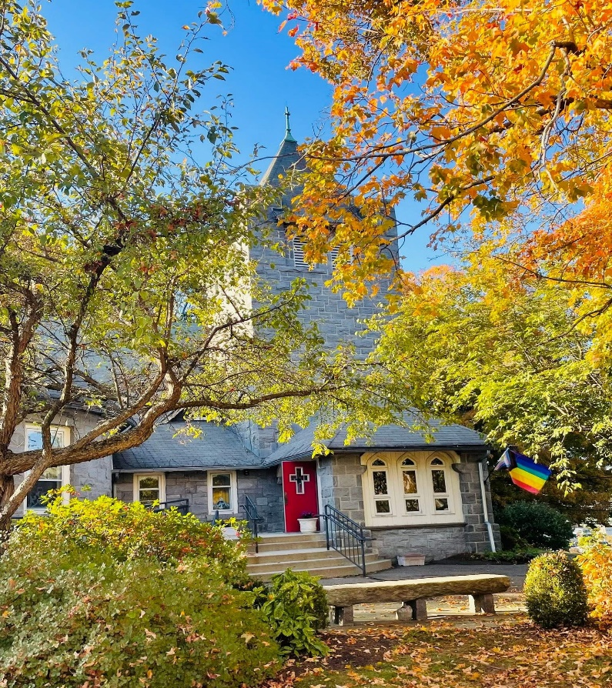

No matter who you are or where you find yourself on
life’s journey, you are welcome here!
____________________________________________


November 23, 2025
Last Sunday After Pentecost

GATHERED FOR WORSHIP
PRELUDE, OPENING PRAYER, WELCOME, & ANNOUNCEMENTS
WORSHIP IN SONG
THANKSGIVING HYMN: #422 "Come, O Thankful People Come
SONG: “Crowded Table,” The Highwomen
Verse 1: You can hold my hand, When you need to let go
I can be your mountain, When you're feeling valley-low
I can be your streetlight, Showing you the way home
You can hold my hand, When you need to let go
Chorus: I want a house with a crowded table, And a place by the fire for everyone, Let us take on the world while we're young and able, And bring us back together when the day is done
Verse 2: If we want a garden, We're gonna have to sow the seed, Plant a little happiness, Let the roots run deep, If it's love that we give, Then it's love that we reap, If we want a garden, We're gonna have to sow the seed
Chorus: Yeah I want a house with a crowded table, And a place by the fire for everyone, Let us take on the world while we're young and able, And bring us back together when the day is done
Bridge: The door is always open, Your picture's on my wall
Everyone's a little broken, And everyone belongs, Yeah, everyone belongs
Chorus: I want a house with a crowded table, And a place by the fire for everyone, Let us take on the world while we're young and able, And bring us back together when the day is done, And bring us back together when the day is done

HYMN: “We Gather Together” (Kremser)
Verse 1: We gather together, To ask the Lord's blessing
He chastens and hastens, His will to make known
The wicked oppressing, Now cease from distressing
Sing praises to His name, He forgets not His own
Verse 2: Beside us to guide us, Our God with us joining, Ordaining maintaining, His kingdom divine, So from the beginning, The fight we were winning, Thou Lord wast at our side, All glory be Thine
Verse 3: We all do extol Thee, Thou Leader triumphant, And pray that Thou still, Our Defender wilt be, Let Thy congregation, Escape tribulation
Thy name be ever praised, O Lord make us free
Eduard Kremser, Theodore Baker, CCLI Song #91678, © Words: Public Domain; Music: Public Domain, For use solely with the SongSelect® Terms of Use. All rights reserved. www.ccli.com
*PRAYER OF CONFESSION: Gracious God, we draw near to you admitting that we have not always been grateful. We enjoy such plenty: food, clothing, and shelter, and too often take it for granted. We remember this morning, so many who lack these necessities. Forgive us, and give us hearts filled with gratitude. Amen.

*WORDS OF ASSURANCE AND THE PASSING OF PEACE

HEARING THE WORD OF GOD
CHILDREN’S SERMON

JOHN 18: 33-37 Then Pilate entered the headquarters again, summoned Jesus, and asked him, “Are you the King of the Jews?” ³⁴Jesus answered, “Do you ask this on your own, or did others tell you about me?” ³⁵Pilate replied, “I am not a Jew, am I? Your own nation and the chief priests have handed you over to me. What have you done?” ³⁶Jesus answered, “My kingdom is not from this world. If my kingdom were from this world, my followers would be fighting to keep me from being handed over to the Jews. But as it is, my kingdom is not from here.” ³⁷Pilate asked him, “So you are a king?” Jesus answered, “You say that I am a king. For this I was born, and for this I came into the world, to testify to the truth. Everyone who belongs to the truth listens to my voice.”

SERMON: "Thankful for the Truth"

RESPONDING TO THE WORD OF GOD

*HYMN: #300 "Jesus Shall Reign"

JOYS & CONCERNS, PRAYERS OF THE CHURCH, LORD’S PRAYER
Lord, in your mercy… Hear our prayers.

OFFERING:
Thank you for supporting our ministries!
Offerings are gratefully received in the box in the back of the sanctuary, via QR code, or by US post.


