A SERVICE OF LESSONS AND CAROLS FOR CHRISTMAS DAY

PRELUDE, OPENING PRAYER, WELCOME, & ANNOUNCEMENTS

CAROL #138 “Jesus, Our Brother, Strong and Good”

PRAYERS FOR THE WORLD
THE LORD’S PRAYER

GENESIS 1:1-5 God calls creation into being.

CAROL: #168 “O Radiant Christ, Incarnate Word”

GENESIS 22:15-18 God promises to Abraham that by his descendants all the nations of the earth shall obtain blessing.

CAROL: #386 “O Come, All Ye Faithful” (Methodist Hymnal)

ISAIAH 9:2, 6-7 The prophet announces the birth of a king to a people in darkness.

SONG: “Christmas Morning,” The McClures

LUKE 1:26-35, 38 The angel Gabriel announces to Mary that she will give birth to God’s promised Son whose kingdom shall never end.

CAROL: #145 “Once in Royal David’s City”

LUKE 2:1-7 Against a backdrop of emperors and taxes, Jesus is born.

CAROL: #127 “Lo, How a Rose E’er Blooming”

LUKE 2:8-16 The shepherds go to see the Savior of the world, lying in a manger.

SONG: “Christmas Must Be Tonight,” The Band

JOHN 1:1-14 John unfolds the great mystery of the Incarnation.

HYMN: #148 “What Child is This”

REVELATION 21:1-4 John shares his vision of the culmination of God’s plans for creation.

HYMN: #165 “Love Came Down at Christmas”

PRAYER:
Eternal God, by the birth of Jesus Christ you gave yourself to the world. Grant that, being born in our hearts, he may save us from sin and aimlessness, and restore within us the image and likeness of our Creator, to whom be everlasting praise and glory, world without end. Amen

DISMISSAL WITH BLESSING:
May the Christ who by his Incarnation gathered into One things earthly and heavenly, fill you with the sweetness of inward peace and goodwill; and the blessing of God Almighty, the Father, the Son, and the Holy Spirit, be upon you and remain with you always. Amen.
Go forth in peace and joy. Thanks be to God. Alleluia, amen!
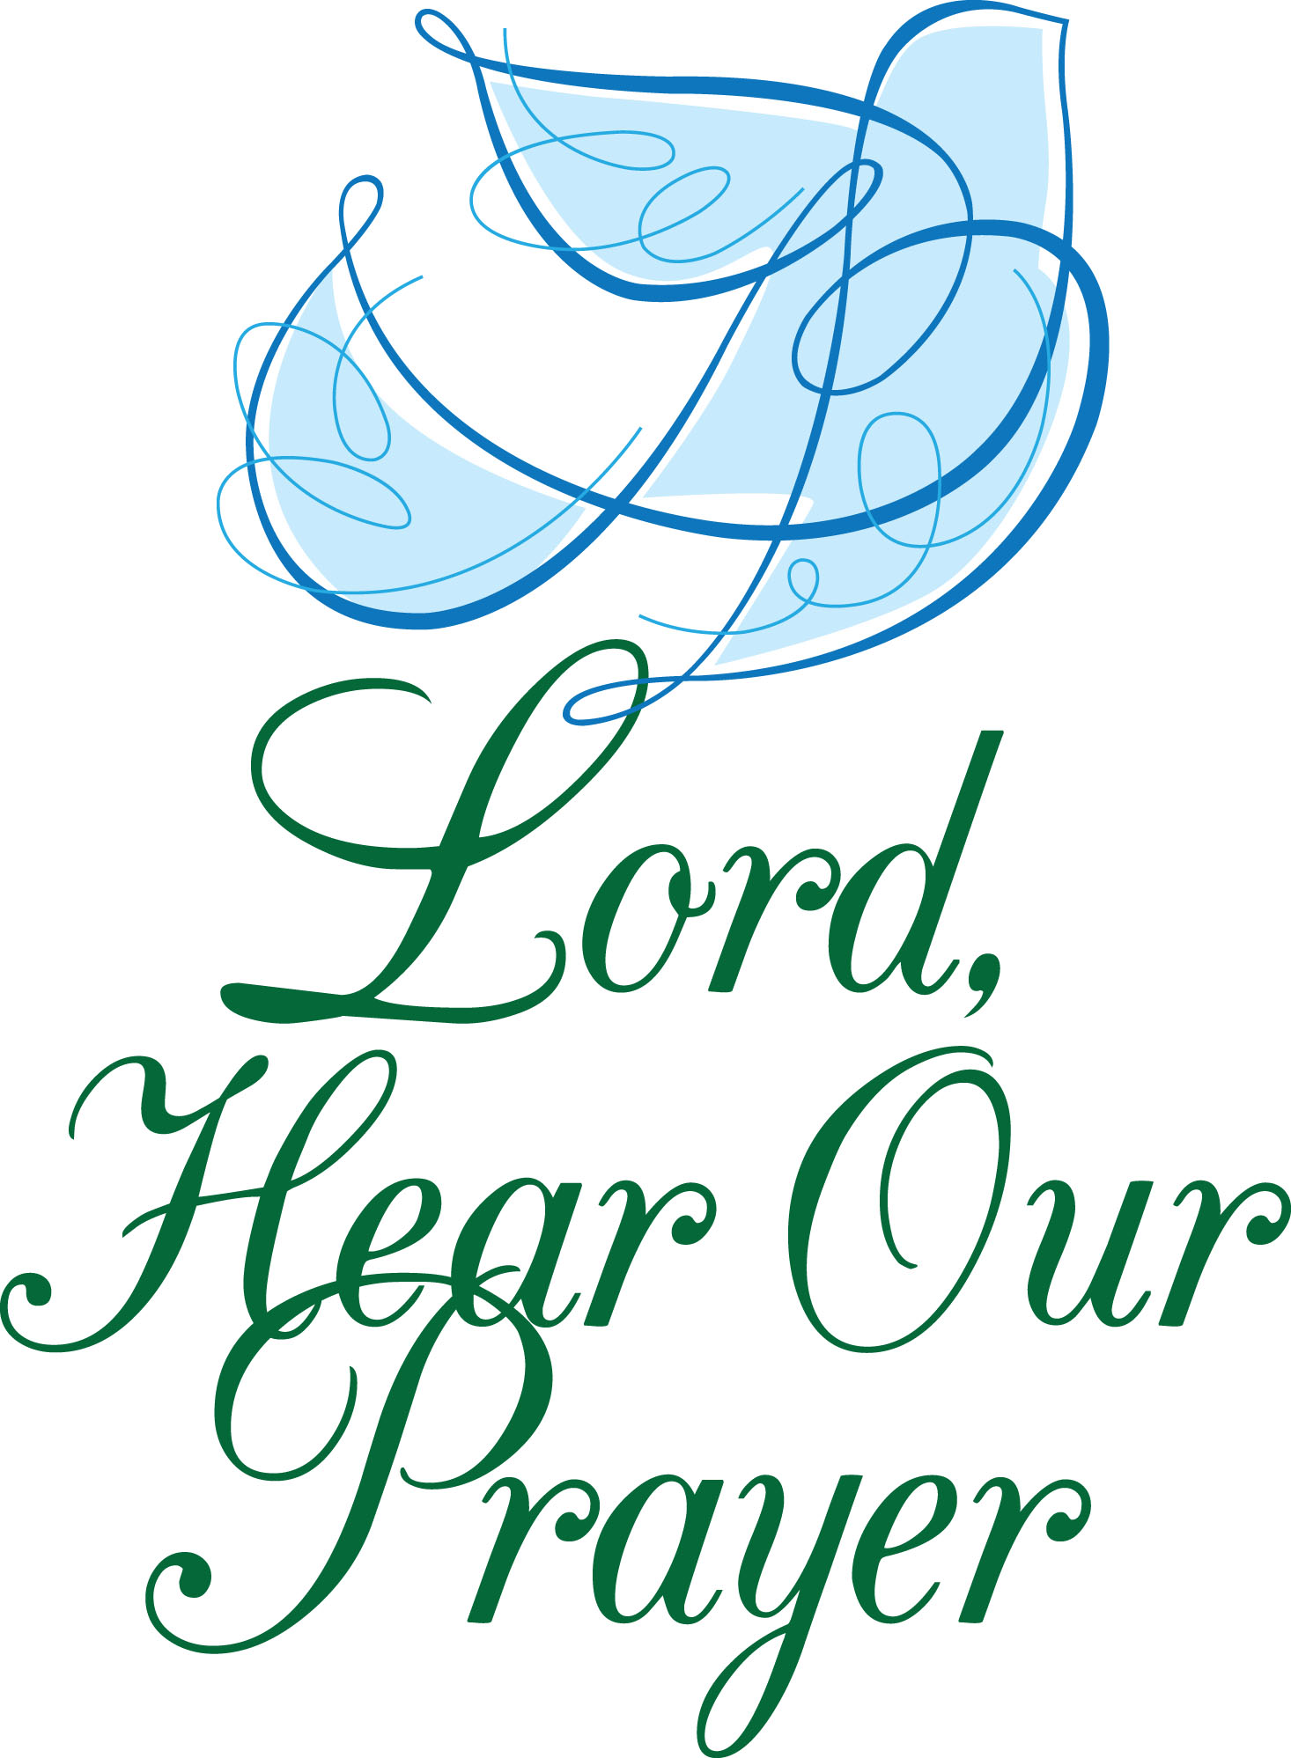

PRAYER LIST
To add to our prayer list please email Pastor Tim with a brief description of your prayer. Please indicate if you would like the prayer to be listed on an ongoing basis. tim.hare@trumbullcc.org.

~Douglas Mihalko, Karolina Szabo’s son’s brother-in-law, diagnosed with cancer
~Rev. Clayton Miller, Pastor Tim’s friend and mentor, at home with health concerns
~Alex Kitchener, baby Clark, and the Kitchener family
~Eric Farrell who struggles with his dialysis treatments while continuing his search for a
live kidney donor: learn more at ynhh.org/organdonation or 866-925-3897.
~Lauren Magnuson whose nephew, Michael Christian Eiby Corwel, and niece, Lara
Edmondson, are both struggling with health issues.
~Linda Trefz recovering from hip surgery.
~Michelle Consolati, continued healing from surgery
~Herb Gratrix, recovering from a fall
~Lori Patrice Murray as she continues her courageous battle going through treatments
for cancer. Please keep her and her family in your prayers.
~Muirgheal Coffin, prayers for continued good health as she struggles with Epilepsy
~Ilana Ofgang, health concerns
~Lisa Gruttadauria, recovering from surgery
~ Rose Heiser, Angela Hare’s mother, struggling with health concerns
OFFICE HOURS:
Please feel free to reach out to Lisa – Mondays, Tuesdays & Thursdays from 9am-12pm at
203-268-2433 or at office@trumbullcc.org. Pastor Tim will be on vacation following the service on Dec. 25 until January 2, 2023. For emergency pastoral care please call Rev. Kathleen Mills at 207-213-3576 or Rev. Todd Shipley at 203-435-8873.
ANNOUNCEMENTS
Poinsettias: If you ordered flowers for the service you are welcome to take them home after the service. Thank you for adding to the beauty of our sanctuary and contributing to our Music Fund. Additional contributions can be made to “TCC” with “Music Fund” in the memo line.
House Church: Jan. 4 at 7pm. Save the date!
Governing Board: Jan. 10 at 7pm.
Valentine's Concert and Gift Basket Raffle: Save the date for a lovely evening of music and fun: Feb. 5, 4 pm.

