GATHERED FOR WORSHIP
4:30pm: Christmas Caroling!
New Century Hymnal #’s 124-181, Methodist Hymnal #’s 373-411

PRELUDE: “Taladh Chriosda, the Christ Child’s Lullaby”
OPENING PRAYER, WELCOME, & ANNOUNCEMENTS

WORSHIP IN SONG
HYMN: #240 “Hark the Herald Angels Sing” (Methodist Hymnal)
SONG: “Soul Cake,” Sting
LIGHTING THE CHRIST CANDLE
HYMN: “Angels We Have Heard On High”
Angels we have heard on high; Sweetly singing o'er the plains
And the mountains in reply; Echoing their joyous strains
Gloria in excelsis Deo

*PRAYER OF REPENTANCE: (responsive)
Holy God, mindful of this season’s call for us to turn anew to you, we ask that you hear our prayers:
Let the love that shaped earth and heaven dwell within us this Christmas.
Let the love that created humanity dwell within us this Christmas.
Let the love that overcomes suffering and hatred dwell within us this Christmas.
Let the love that causes us to rejoice with loved ones dwell within us this Christmas.
Let the love that forgives and renews dwell within us this Christmas.
Let the love that brings reconciliation after separation dwell within us this Christmas.
Let the love that brings the blessing of peace dwell within us this Christmas.
And may we share that peace with all people near and far. Amen.

*WORDS OF ASSURANCE AND THE PASSING OF PEACE
HEARING THE WORD OF GOD
CHILDREN’S SERMON
Special Music: “O Holy Night”
ISAIAH 9:2-7 ² *The people who walked in darkness have seen a great light; those who lived in a land of deep darkness— on them light has shined. ³ You have multiplied the nation, you have increased its joy; they rejoice before you as with joy at the harvest, as people exult when dividing plunder. ⁴ For the yoke of their burden, and the bar across their shoulders, the rod of their oppressor, you have broken as on the day of Midian.
⁵ For all the boots of the tramping warriors and all the garments rolled in blood
shall be burned as fuel for the fire. ⁶ For a child has been born for us,
a son given to us; authority rests upon his shoulders; and he is named
Wonderful Counsellor, Mighty God, Everlasting Father, Prince of Peace.
⁷ His authority shall grow continually, and there shall be endless peace
for the throne of David and his kingdom. He will establish and uphold it
with justice and with righteousness from this time onwards and for evermore.
The zeal of the Lord of hosts will do this.
LUKE 2:1-20 In those days a decree went out from Emperor Augustus that all the world should be registered. ²This was the first registration and was taken while Quirinius was governor of Syria. ³All went to their own towns to be registered. ⁴Joseph also went from the town of Nazareth in Galilee to Judea, to the city of David called Bethlehem, because he was descended from the house and family of David. ⁵He went to be registered with Mary, to whom he was engaged and who was expecting a child. ⁶While they were there, the time came for her to deliver her child. ⁷And she gave birth to her firstborn son and wrapped him in bands of cloth, and laid him in a manger, because there was no place for them in the inn. 8 In that region there were shepherds living in the fields, keeping watch over their flock by night. ⁹Then an angel of the Lord stood before them, and the glory of the Lord shone around them, and they were terrified. ¹⁰But the angel said to them, ‘Do not be afraid; for see—I am bringing you good news of great joy for all the people: ¹¹to you is born this day in the city of David a Saviour, who is the Messiah,* the Lord. ¹²This will be a sign for you: you will find a child wrapped in bands of cloth and lying in a manger.’ ¹³And suddenly there was with the angel a multitude of the heavenly host,* praising God and saying, ¹⁴ ‘Glory to God in the highest heaven, and on earth peace among those whom he favours!’*
15 When the angels had left them and gone into heaven, the shepherds said to one another, ‘Let us go now to Bethlehem and see this thing that has taken place, which the Lord has made known to us.’ ¹⁶So they went with haste and found Mary and Joseph, and the child lying in the manger. ¹⁷When they saw this, they made known what had been told them about this child; ¹⁸and all who heard it were amazed at what the shepherds told them. ¹⁹But Mary treasured all these words and pondered them in her heart. ²⁰The shepherds returned, glorifying and praising God for all they had heard and seen, as it had been told them.
SERMON
RESPONDING TO THE WORD OF GOD
*HYMN: #126 “Angels from the Realms of Glory” (New Century Hymnal)

PASTORAL PRAYER
THE LORD’S PRAYER (“debts/debtors”)

OFFERING: Thank you for supporting our ministries!

HYMN: #393 “Silent Night, Holy Night” (Methodist Hymnal)
We light our candles during this time and share the light of Christ.

SENT TO SERVE

BENEDICTION

*SONG: #132 “Joy to the World”
Joy to the world, the Lord is come! Let earth receive her King;
Let every heart prepare him room, and heaven and nature sing,
And heaven and nature sing, and heaven, and heaven, and nature sing.
Joy to the world, the Savior reigns! Let all their songs employ;
While fields and floods, rocks, hills, and plains, repeat the sounding joy,
Repeat the sounding joy, repeat, repeat the sounding joy.

*POSTLUDE
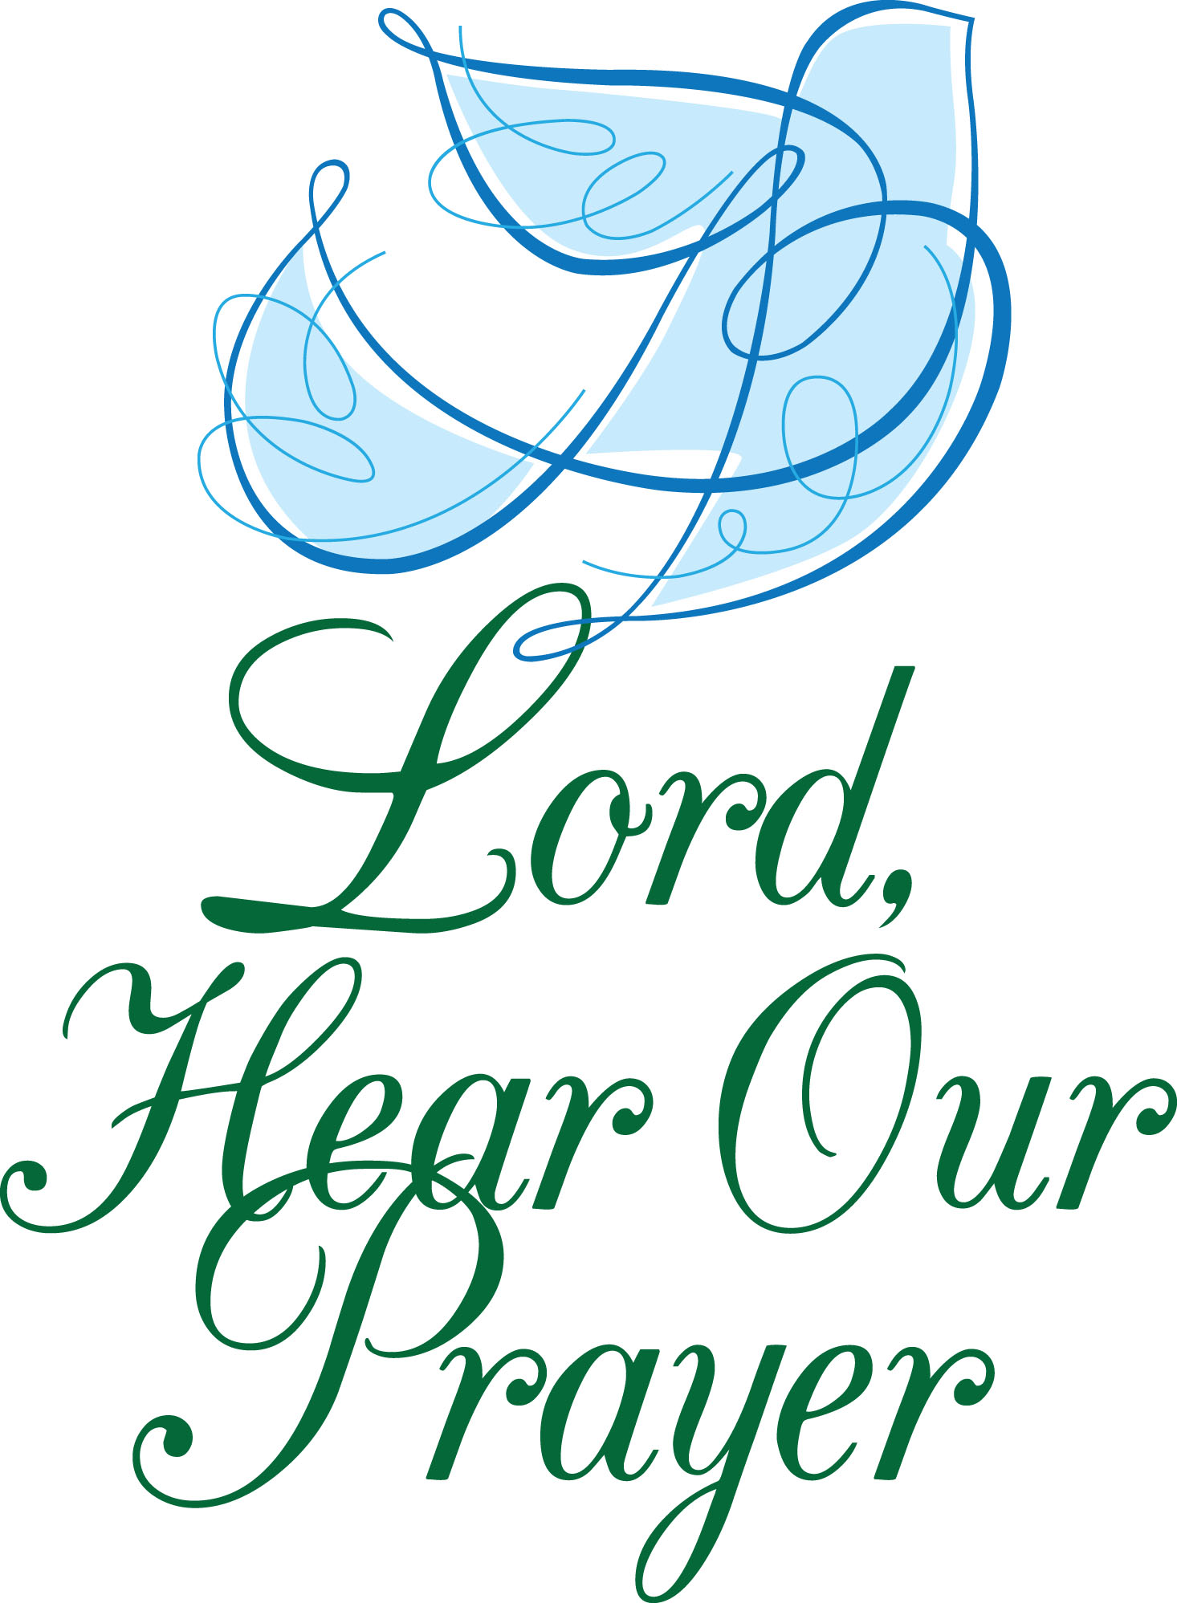

PRAYER LIST
To add to our prayer list please email Pastor Tim with a brief description of your prayer. Please indicate if you would like the prayer to be listed on an ongoing basis. tim.hare@trumbullcc.org.

~Douglas Mihalko, Karolina Szabo’s son’s brother-in-law, diagnosed with cancer
~Rev. Clayton Miller, Pastor Tim’s friend and mentor, at home with health concerns
~Alex Kitchener, baby Clark, and the Kitchener family
~Eric Farrell who struggles with his dialysis treatments while continuing his search for a
live kidney donor: learn more at ynhh.org/organdonation or 866-925-3897.
~Lauren Magnuson whose nephew, Michael Christian Eiby Corwel, and niece, Lara
Edmondson, are both struggling with health issues.
~Linda Trefz recovering from hip surgery.
~Michelle Consolati, continued healing from surgery
~Herb Gratrix, recovering from a fall
~Lori Patrice Murray as she continues her courageous battle going through treatments
for cancer. Please keep her and her family in your prayers.
~Muirgheal Coffin, prayers for continued good health as she struggles with Epilepsy
~Ilana Ofgang, health concerns
~Lisa Gruttadauria, recovering from surgery
~ Rose Heiser, Angela Hare’s mother, struggling with health concerns

OFFICE HOURS:
Please feel free to reach out to Lisa – Mondays, Tuesdays & Thursdays from 9am-12pm at
203-268-2433 or at office@trumbullcc.org. Also, Pastor Tim will be on vacation following the service on Dec. 25 until January 2, 2023. For emergency pastoral care please call Rev. Kathleen Mills at 207-213-3576 or Rev. Todd Shipley at 203-435-8873.

ANNOUNCEMENTS
Poinsettias: If you ordered flowers for the service you are welcome to take them home after the service. Thank you for adding to the beauty of our sanctuary and contributing to our Music Fund. Additional contributions can be made to “TCC” with “Music Fund” in the memo line.
House Church: Jan. 4 at 7pm. Save the date!
Governing Board: Jan. 10 at 7pm.
Valentine's Concert and Gift Basket Raffle: Save the date for a lovely evening of
music and fun: Feb. 5, 4pm.

