August 7, 2022

PRELUDE, OPENING PRAYER, WELCOME, & ANNOUNCEMENTS
WORSHIP IN SONG
SONG: “Because He Lives”

Chorus: Because He lives I can face tomorrow; Because He lives all fear is gone; Because I know He holds the future; And life is worth the living; Just because He lives

SONG: “Bridge Over Troubled Water,” Paul Simon
HYMN: “Spirit of the Living God”

Spirit of the Living God; Fall fresh on me; Spirit of the Living God; Fall fresh on me Melt me mold me; Fill me use me; Spirit of the Living God; Fall fresh on me

PRAYER OF CONFESSION, PARDON, AND PEACE
Gracious God of us all, we gather in your name. We come to worship, and to reflect and grow in our understanding of what it means to recognize you in our lives and life together. To do this, we must confess those times and places where we have become complacent in our relationship with you. It is not that we don't care. It is more that we take this relationship for granted and do not remain diligent. As a result, we are caught unaware of how you are moving in our lives and life together.
For these acts and so many others, we seek your healing grace. Help us to remain alert. Empower us that we may offer to others what you offer to us. We ask this all in Jesus' name. Amen.

LUKE 10:38-42
38 Now as they went on their way, he entered a certain village, where a woman named Martha welcomed him into her home. ³⁹She had a sister named Mary, who sat at the Lord’s feet and listened to what he was saying. ⁴⁰But Martha was distracted by her many tasks; so she came to him and asked, ‘Lord, do you not care that my sister has left me to do all the work by myself? Tell her then to help me.’ ⁴¹But the Lord answered her, ‘Martha, Martha, you are worried and distracted by many things; ⁴²there is need of only one thing.* Mary has chosen the better part, which will not be taken away from her.’

SERMON: "Knowing When"

*HYMN: #421"We Gather Together"

JOYS & CONCERNS, PRAYERS OF THE CHURCH, LORD’S PRAYER
Lord, in your mercy… Hear our prayers.

OFFERING: Thank you for supporting our ministries!

PRAYER OF GREAT THANKSGIVING WITH HOLY COMMUNION

PRAYER AFTER COMMUNION

SONG: “Seek First”

Chorus: I will seek first Your Kingdom; I will seek first Your righteousness; Everything I need You will provide for me; My heart is to seek ﬁrst Your Kingdom

BENEDICTION & POSTLUDE

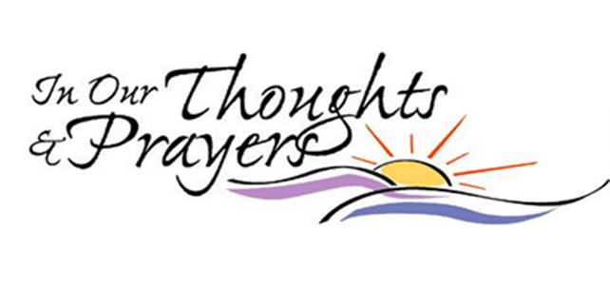
To add to our prayer list please email Pastor Tim with a brief description of your prayer. Please indicate if you would like the prayer to be listed on an ongoing basis. tim.hare@trumbullcc.org.

~Bob & Rita Bennett, prayers for healing
~Mitchel Archer, continued recovery and help with new prostheses
~Muirgheal Coffin, prayers for continued good health as she struggles with seizure disorder
~The Balogh Family grieving the loss of Mary after a very courageous battle with cancer.
~Douglas Mihalko, Karolina Szabo’s son’s brother-in-law, diagnosed with cancer
~Oliver Tiesler, born on April 12 to Sophie and Paul! Praise God!
~Trevor Vincent Sando, born on April 11 to Emily and Matt! Praise God again!
~Michelle Consolati as she recovers from hip surgery.
~Tim & his wife Allison welcomed Austin Nicholas Crowle into the world on July 2nd Praise God!

Rev. Eric Fjeldal
Rev. Eric Fjeldal, a retired United Methodist Pastor, served seven churches during his 43 years of pastoral ministry. In addition, he has served part-time as a Chaplain in a private Psychiatric Hospital and as a Chaplain for a Hospice Program.
Eric, a graduate of Drew Theological Seminary in May of 1979, was ordained a Deacon in the New York Annual Conference in 1978, and an elder in 1982. He retired from full-time ministry in June, 2021. In retirement, Eric does guest preaching and preached at TCC last summer. He also works part-time at a Funeral Home. Eric enjoys spending time with his family, especially his wife, Renee and their two grandchildren.

CCLI Song # 16880 Gaither © 1971 Hanna Street Music CCLI License # 11353163
CCLI Song # 23488 License # 11353163 Iverson © Words: 1935. Renewed 1963 Birdwing
CCLI Song # 7053763 Smith | Upton © 2014 Key Of David Music CCLI License # 11353163

