July 17, 2022

PRELUDE
INTROIT: “Spirit of the Living God”
Spirit of the Living God; Fall fresh on me; Spirit of the Living God; Fall fresh on me Melt me mold me; Fill me use me; Spirit of the Living God; Fall fresh on me
OPENING PRAYER, WELCOME, & ANNOUNCEMENTS
OPENING HYMN: #70 God is Here

PRAYER OF CONFESSION, PARDON, AND PEACE: O God, You alone know our inmost selves. We cannot hide from Your presence. We claim to be followers of Jesus, but often prefer to control every aspect of our lives. Forgive us and restore us to a right relationship with You through Christ our Lord. Amen.

WORDS OF ASSURANCE AND PEACE
CHILDREN’S SERMON: “Follow the Leader”
MATTHEW 4:12-22
12 Now when Jesus* heard that John had been arrested, he withdrew to Galilee. ¹³He left Nazareth and made his home in Capernaum by the lake, in the territory of Zebulun and Naphtali, ¹⁴so that what had been spoken through the prophet Isaiah might be fulfilled:
¹⁵ ‘Land of Zebulun, land of Naphtali, on the road by the sea, across the Jordan, Galilee of the Gentiles— ¹⁶ the people who sat in darkness have seen a great light,
and for those who sat in the region and shadow of death light has dawned.’
¹⁷From that time Jesus began to proclaim, ‘Repent, for the kingdom of heaven has come near.’* 18 As he walked by the Sea of Galilee, he saw two brothers, Simon, who is called Peter, and Andrew his brother, casting a net into the lake—for they were fishermen. ¹⁹And he said to them, ‘Follow me, and I will make you fish for people.’ ²⁰Immediately they left their nets and followed him. ²¹As he went from there, he saw two other brothers, James son of Zebedee and his brother John, in the boat with their father Zebedee, mending their nets, and he called them. ²²Immediately they left the boat and their father, and followed him.
SERMON: “Sailboat Spirituality”
*SONG RESPONSE: “Lead me Lord” (insert – on back) sing twice
JOYS & CONCERNS, PRAYERS OF THE CHURCH, LORD’S PRAYER
Lord, in your mercy… Hear our prayers.
OFFERING: Thank you for supporting our ministries!
PRAYER OF THANKSGIVING
*DOXOLOGY #780
BENEDICTION
*CLOSING HYMN: #493 “O Jesus, I Have Promised”
POSTLUDE
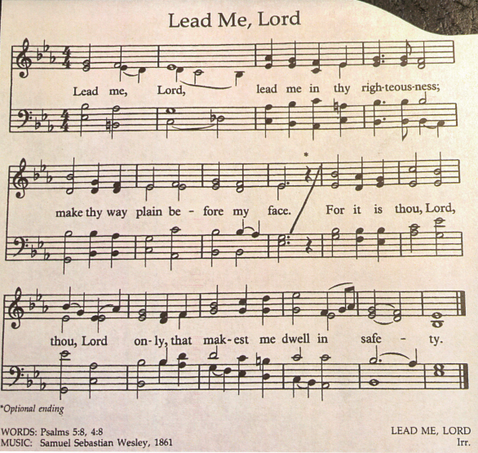

Meet Rev. Caroly Gibson: Rev. Caroly Gibson is a retired United Methodist pastor. She has served churches in CT at Woodbury, Fairfield, Greenwich, and Milford. In retirement, Caroly has served as interim pastor in Wilton and Monroe. Guest preaching, teaching, and leading retreats keep her in active ministry. Caroly and her husband Bruce live here in Trumbull and enjoy worshiping with this TCC Community.

CCLI Song # 23488 License # 11353163 Iverson © Words: 1935. Renewed 1963 Birdwing

