June 5, 2022

PRELUDE, OPENING PRAYER, WELCOME, & ANNOUNCEMENTS
WORSHIP IN SONG
SONG: “Spirit of God Bright Wind”
Verse 1: Spirit of God, bright Wind, breath that bids life begin, glow as you always do; create us anew. Give us the breath to sing, lifted on soaring wing, held in your hands, born on your wings.
Chorus: Alleluia! Come, Spirit, Come! (2 times)
Verse 2: Spirit of God, bright Dove, grant us your peace and love, healing upon your wings for all living things. For when we live your peace, captives will find release, held in your hands, born on your wings.
Chorus: Alleluia! Come, Spirit, Come! (2 times)
Verse 5: Spirit of God, bright Flame, send us in your holy name, the power to heal, to share your love everywhere. We cannot fail or fall, or know defeat at all, held in your hands, born on your wings.
Chorus: Alleluia! Come, Spirit, Come! (2 times)
SONG: “Full Force Gale, ” Van Morrison
HYMN: “Spirit of the Living God”
Spirit of the Living God; Fall fresh on me; Spirit of the Living God; Fall fresh on me Melt me mold me; Fill me use me; Spirit of the Living God; Fall fresh on me

PRAYER OF CONFESSION, PARDON, AND PEACE
Gracious God, we come before you as a people too nearly conformed to this world and its values.We fail to care for the development of our spirits and we neglect the nurture of our own best selves. We ignore our own hunger and thirst for you. Transform us by your Spirit and renew our minds. May we find the joy and peace that come from seeking your will, through Jesus, your faithful servant. Amen.

ACTS 2: 1-8
2When the day of Pentecost had come, they were all together in one place. ²And suddenly from heaven there came a sound like the rush of a violent wind, and it filled the entire house where they were sitting. ³Divided tongues, as of fire, appeared among them, and a tongue rested on each of them. ⁴All of them were filled with the Holy Spirit and began to speak in other languages, as the Spirit gave them ability.5 Now there were devout Jews from every nation under heaven living in Jerusalem. ⁶And at this sound the crowd gathered and was bewildered, because each one heard them speaking in the native language of each. ⁷Amazed and astonished, they asked, ‘Are not all these who are speaking Galileans? ⁸And how is it that we hear, each of us, in our own native language?

GALATIANS 3: 26-29
²⁶for in Christ Jesus you are all children of God through faith. ²⁷As many of you as were baptized into Christ have clothed yourselves with Christ. ²⁸There is no longer Jew or Greek, there is no longer slave or free, there is no longer male and female; for all of you are one in Christ Jesus. ²⁹And if you belong to Christ, then you are Abraham’s offspring,* heirs according to the promise.

SERMON: "Imagine the Reality of Us" Rev. Caroly R. Gibson

*HYMN: #290 “Spirit of God Descend upon My Heart”

JOYS & CONCERNS, PRAYERS OF THE CHURCH, LORD’S PRAYER
Lord, in your mercy… Hear our prayers.

OFFERING: Thank you for supporting our ministries!

PRAYER OF GREAT THANKSGIVING WITH HOLY COMMUNION

HYMN: #346 “Bread of the World in Mercy Broken”

PRAYER AFTER COMMUNION

SONG: “Freedom”
Pre-Chorus: Run into wide open spaces; Grace is waiting for you; Dance like the weight has been lifted; Grace is waiting

Chorus: Where the Spirit of the Lord is there is freedom; There is freedom; Where the Spirit of the Lord is there is freedom; There is freedom; Come out of the dark just as you are Into the fullness of His love; For the Spirit is here let there be freedom; Let there be freedom

Pre-Chorus: Dance like the weight has been lifted; Grace is waiting
BENEDICTION & POSTLUDE

Meet Caroly Gibson: Rev. Caroly Gibson is a retired United Methodist pastor. She has served churches in CT at Woodbury, Fairfield, Greenwich, and Milford. In retirement, Caroly has served as interim pastor in Wilton and Monroe. Guest preaching, teaching, and leading retreats keep her in active ministry. Caroly and her husband Bruce live here in Trumbull and enjoy worshiping with this TCC Community.

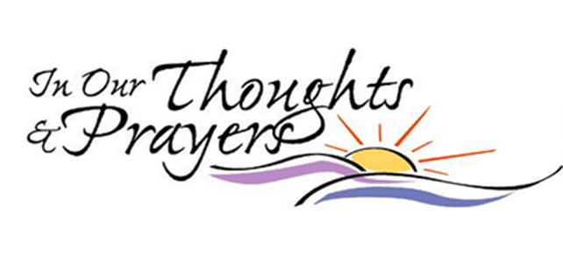

PRAYER LIST

To add to our prayer list please email Pastor Tim with a brief description of your prayer. Please indicate if you would like the prayer to be listed on an ongoing basis. tim.hare@trumbullcc.org.

Bob & Rita Bennett, prayers for healing

Mitchel Archer, continued recovery and help with new prostheses

Muirgheal Coffin, prayers for continued good health as she struggles with seizure disorder

The Balogh Family grieving the loss of Mary after a very courageous battle with cancer.

Linda Mancinelli, cancer free and recovering well from surgery!

Douglas Mihalko, Karolina Szabo’s son’s brother in law, diagnosed with cancer

Oliver Tiesler, born on April 12 to Sophie and Paul! Praise God!

Trevor Vincent Sando, born on April 11 to Emily and Matt! Praise God again!

Michelle Consolati as she prepares for hip surgery.

CCLI Song # 23488 License # 11353163 Iverson © Words: 1935. Renewed 1963 Birdwing
CCLI Song # 7078151 Younker et. al. © Capitol CMG Genesis CCLI License # 11353163

