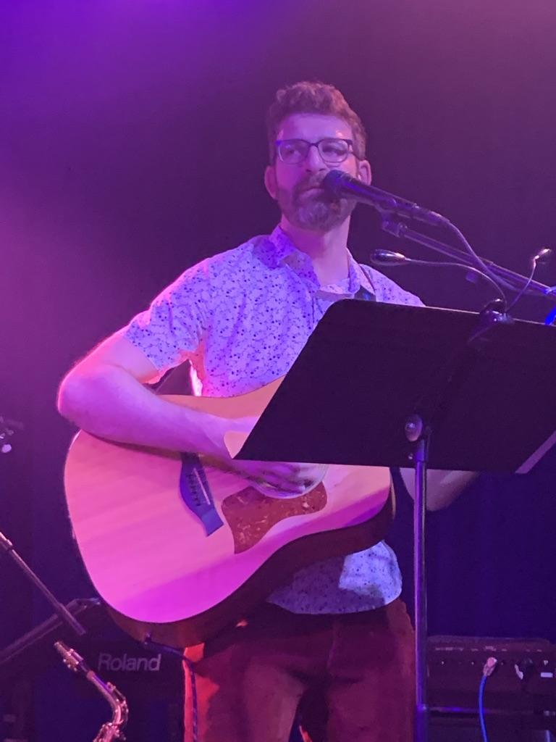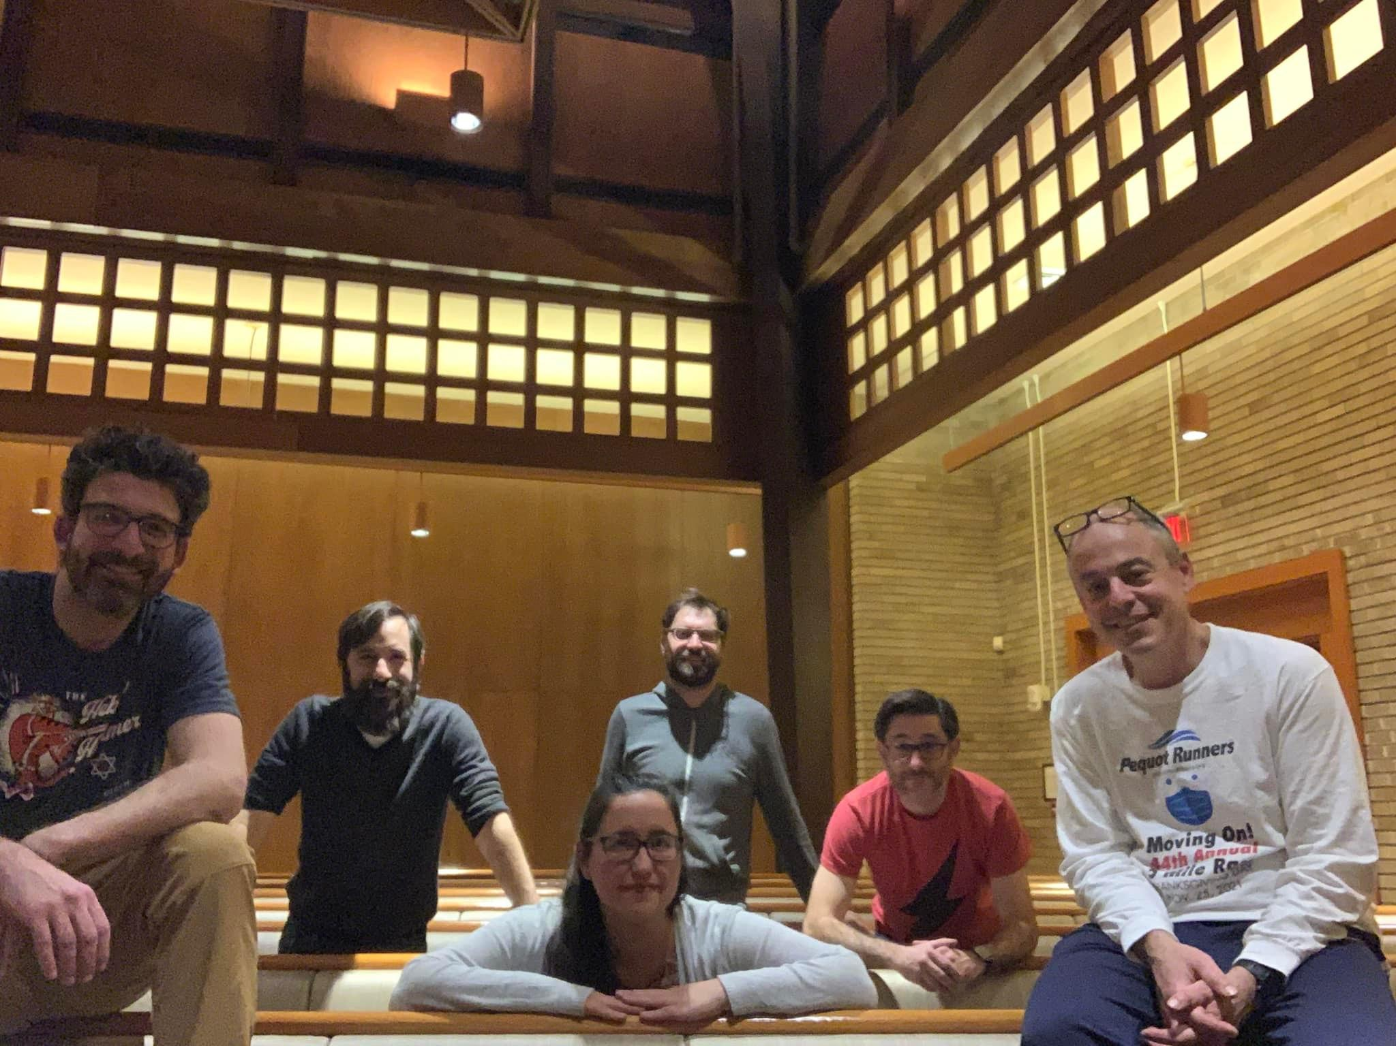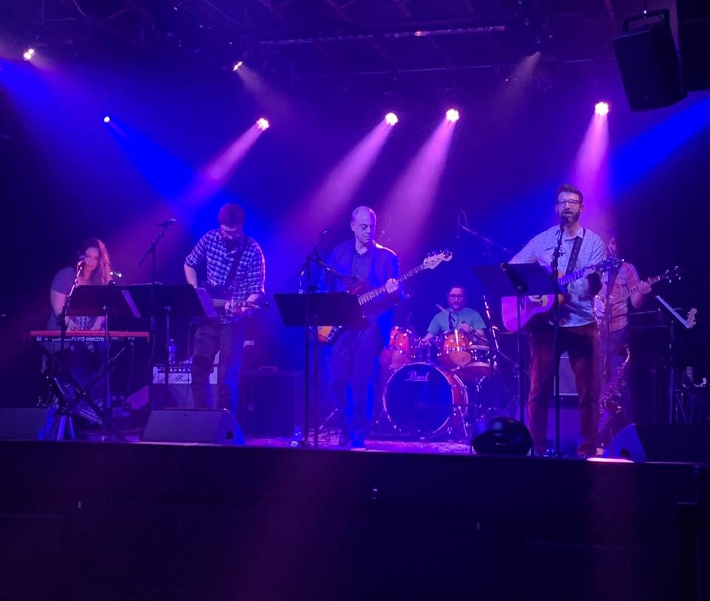

A Community Concert featuring

Electric Sanctuary
Saturday, June 11th
4-6pm

At Trumbull Congregational Church,
3115 Reservoir Ave., Trumbull, CT
Free and open to the public
(donations accepted and appreciated)

Join us for a fun, family friendly musical afternoon featuring Electric Sanctuary.
Led by the rock ‘n’ roll Rabbi Evan Schultz (Senior Rabbi at Congregation B’nai Israel in Bridgeport), Electric Sanctuary is a group of dynamic musicians playing pop, folk, rock, and jamband hits that will nourish the soul and foster good vibes. Bring some chairs, a picnic, BYOB…there will be a 50/50 raffle, fun surprises, and snacks.

This is a free, all ages concert, and all are welcome. Don’t miss it!
Questions? Email Ilana at: ilana.ofgang@trumbullcc.org

