Trumbull Congregational Church
is hosting a concert on the lawn
Saturday May 22, 2021 from 3-4:30 pm.
Please come with your mask on,
bring chairs or a blanket to sit on and relax to wonderful music by
“Once Removed”
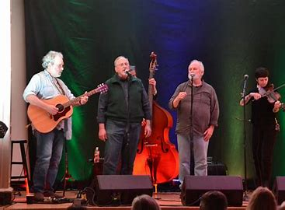

Concert is free but Food donations are being collected for a pantry in Bridgeport.

