Fall Retreat
“In God’s Care”
(Reflections on Psalm 23)

WISDOM HOUSE
229 East Litchfield Rd.
Litchfield, CT 06759
September 24-26, 2021
(Friday, 7:00 p.m. -
Sunday after lunch)

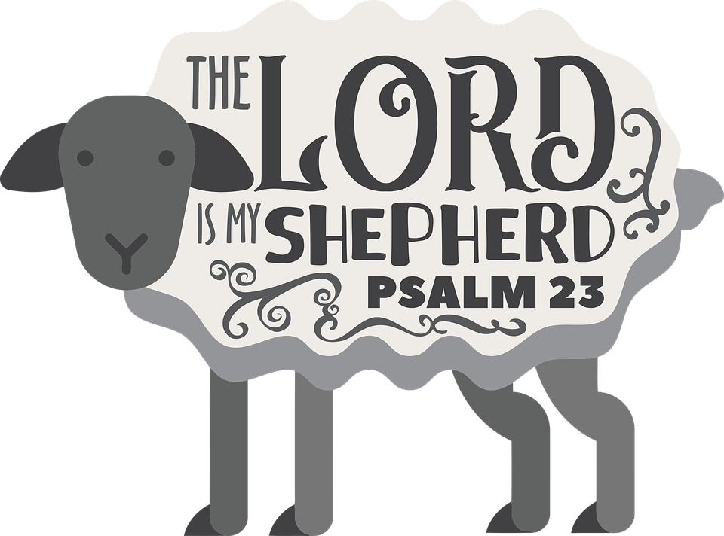
The 23rd Psalm is perhaps the most familiar passage in the entire Bible. Those of us who live in urban and suburban settings are unfamiliar with subjects like sheep, wheat, and soil. In our consumer-oriented society, it is difficult to hear the simple but radical message of this beautiful poetry. Psalm 23 challenges us to affirm that we can put our trust wholly in God’s care.

Led by Reverend Caroly R. Gibson
Total Cost $245.00 (includes 5 meals, room, program, and materials)
Register Soon - Space is Limited - Full Covid Vaccination Required

Name:___________________________________________Email:___________________________________________

Address:___________________________________________________________________________________________

Phone: ( ) Special Diet:_____________________________________

Mail Registration with $150.00 deposit to:
Rev. Caroly Gibson 145 Hilltop Drive Trumbull, CT 06611
Balance due by September 1st

Questions or Further Details, call (203) 380 - 1260 email: cbcgibson88@gmail.com

